DATABASE MANAGEMENT SYSTEMS

Prepared by:  Paul Yun, Collin Woodruff, and Colby Wellens

Elementary School Database

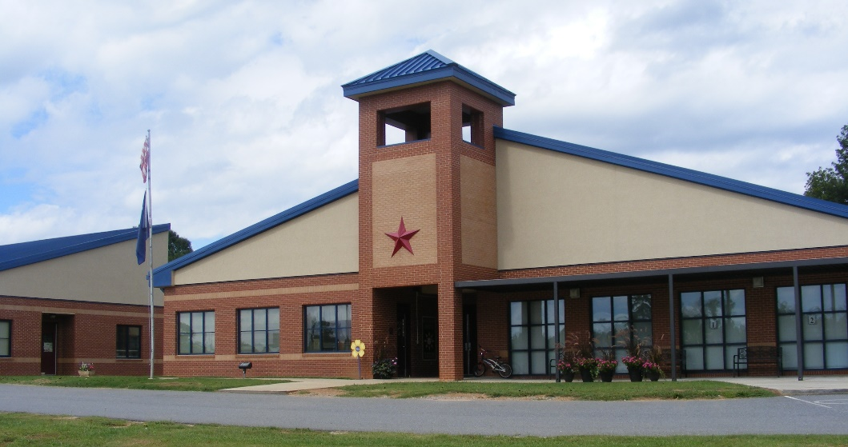

Contents

Team Members 1

Introduction 2

Process Description 2

User Requirements 3

Entity Relationship Diagram 4

Assumptions: 4

Task List 5

Conclusion: 6

# Team Members

* Paul Yun – Comp. Sci. Major
* Collin Woodruff – Comp. Sci. Major with a Software Engineering Track
* Colby Wellens- Comp. Sci. Major

# Introduction

For our database project, we plan to create a database system that manages records for any school which requires information to be stored. We will keep data on the employees of the school as well as the students. Students, parents, and employees alike will be able to access this database. However, they will have certain restrictions on the data they can access depending on their position and current affiliation with the school (status / Still a student? Expelled? Graduated?). Classes, grades, and assignments will be available for students, teachers, and parents.

The departments include Math, Science, Literature, English, Fine Arts, Social Sciences, Health & Physical Education, Computers & Technology, and Mass Communications. Teachers/ Counselors will have restricted access to view or update all of their students’ information (update relevant grades, view courses taken, and view courses required), while students and parents can only view information pertaining to the student (demographic information, grades, assignments, financial bills). Administrators will have access to ALL information regarding student and employees. On top of this, we will also organize the data by department for the employees, and by grade level for students. Information (ssn, supervisor’s ssn, salary, name, etc.) on the employees (teachers, advisors, maintenance, etc.).

## Process Description

### User Requirements

# Entity Relationship Diagram

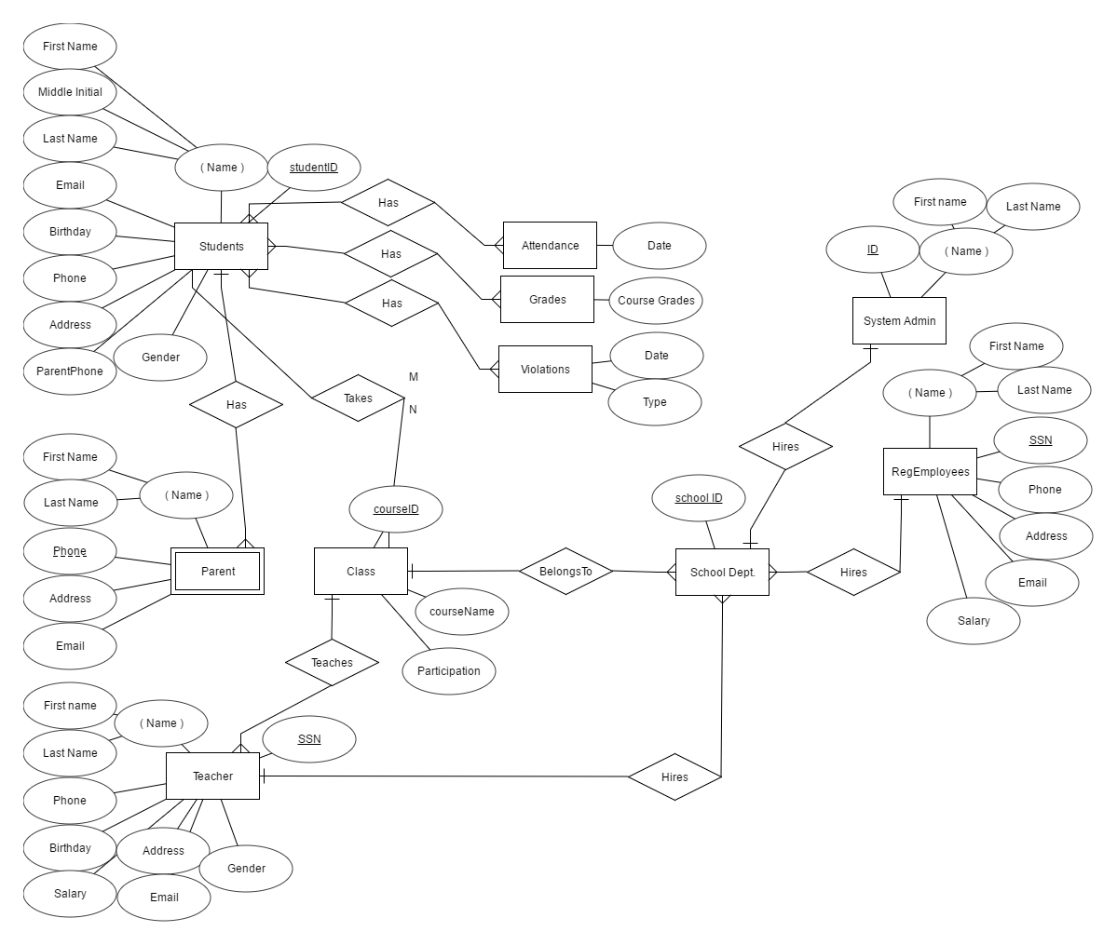

## Assumptions:

* Every student has a parent
* Every school dept. has at least one employee
* Every class has a teacher and at least one student

### Task List

|  |  |  |  |
| --- | --- | --- | --- |
| **Task Name** | **Start** | **Finish** | **Duration** |
| Creating Project Outline | 2/7/2017 | 2/17/2017 | 10 days |
| Writing Paper to outline the project | 2/15/2017 | 2/28/2017 | 13 days |
| Finalizing requirements and specifics | 2/19/2017 | 3/4/2017 | 13 days |
| ER Diagram Roughdraft | 2/27/2017 | 3/7/2017 | 8 days |
| Schema Roughdraft | 3/8/2017 | 3/18/2017 | 10 days |
| Completing Diagrams | 3/19/2017 | 4/4/2017 | 16 days |
| Writing code for the website | 4/5/2017 | 4/23/2017 | 18 days |
| Writing code for the database | 4/19/2017 | 5/6/2017 | 17 days |
| Connecting website and database | 5/2/2017 | 5/14/2017 | 12 days |
| Writing reference manual | 5/7/2017 | 5/17/2017 | 10 days |
| Creating Gantt chart | 5/15/2017 | 5/18/2017 | 3 days |
| Making final PowerPoint | 5/17/2017 | 5/19/2017 | 2 days |

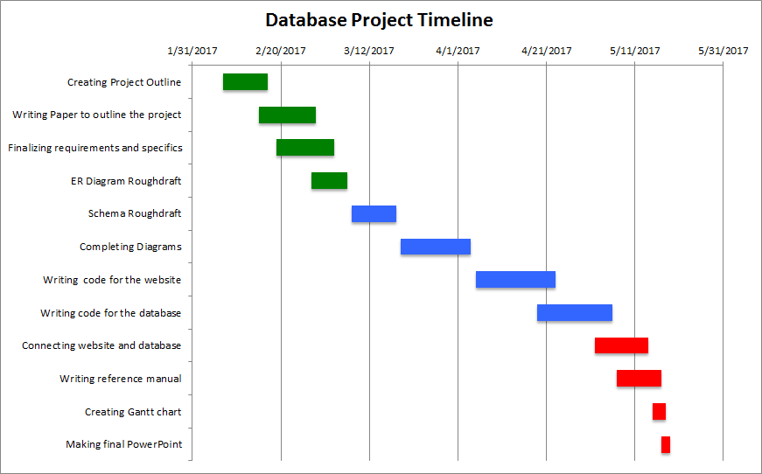

# Conclusion:

We learned a lot from working on this project. We could implement a functional database into